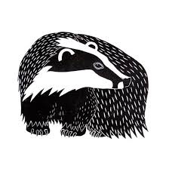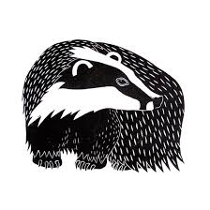

Animals including humans: Life Cycles & Health.

We will be looking at different animal life cycles, including humans and exploring the needs of different living things.

The children will be learning about personal hygiene and ways in which they can promote this independently. We will also explore the positive effects of exercise and look at some of the different food groups.

**We are reading…**

We are having a real push on handwriting this term and focusing on creating the perfect sentence structure. We will do this by looking at using the correct punctuation, using conjunctions and increasing our vocabulary choices. For World Book Day, we are dressing up as animals linking to the ‘An Interview with’ series by Andy Seed. We will be looking into the book ‘An interview with a Shark’ with an outcome of writing out own interview with our chosen animal. We will also learn how to write a list correctly with guidance from the book ‘How to wash a Woolly Mammoth’.

**English**

.

Year One

The children will continue revising previously learnt graphemes as well as learning new alternative sounds. The spellings set each week will match the new sounds covered in class. We will also be preparing the children ready for the phonics screening test in June.

Year Two

We will be starting Fluency of Spelling in Year Two which looks further into different spelling rules and patterns. Their spellings will link to each week.

**Maths**

**Phonics/Spelling**

Understanding Christianity: What do Christians believe God is like?

We will explore different bible stories and bible passages in order to discuss our ideas, to answer the key question about God.

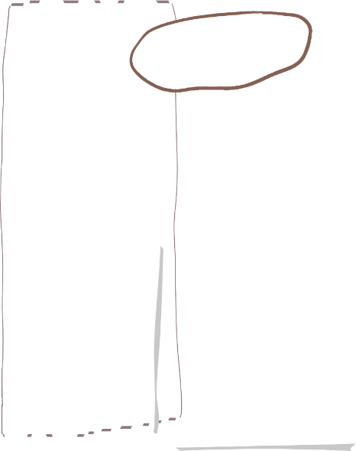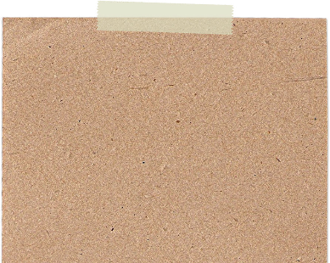

The half term will begin with building the foundations for our multiplication skills. We will look at equal groups, adding equal groups and creating repeated addition number sentences and making the link to multiplication.

We will then look at division and how this begins as sharing into equal groups. The children will then look to divide by 2, 5 and 10 using practical objects and our multiplication skills to support. We will review key mathematical language and continue to develop our problem solving skills.

We are reading……

‘An interview with a…’

By Andy Seed. We will be looking at his ‘An Interview With’ series with the children. They interview different animals and give the animals perspective on life and the world they live in whilst being very funny!

**RE**

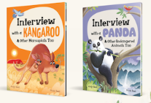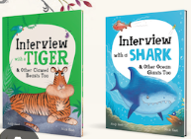

**Weekly Events**

Tuesday – PE

Friday – PE

Friday – Spelling check

**Science**

**Newton Tony Primary School CE VC**

**Spring Term 1 –Foxes learning journey.**

aWe will be improving our swimming skills at Five Rivers Swimming pool this half term, a very important life skill. 

**Cooking & Nutrition: Smoothies**

In this DT unit the children will learn what a fruit is, where different fruits come from. This will then extend to the cutting and juicing of fruits and discussions regarding food preparation. The children will then taste different fruits in order to select ingredients to create their own smoothie recipe. We will then make the smoothie and evaluate.

This unit of work was moved from Spring 1.

This term in Computing, the children will complete one internet safety session and will look into using Scratch Jr and Turtle Logo. The children will learn to programme using Scratch Jr and Turtle Logo and be able to create, debug and complete algorithms. Following on from the earlier units on Preparing for Turtle Logo, the children will use the basic commands in Logo to move and draw using the turtle on screen, and then further develop algorithms using the “repeat” command. These skills are then developed by teaching children to create algorithms in

Scratch using a selection of blocks.

Dynamics, timbre, tempo & motifs : Space

The children will listen to a space themed track and will look to identify elements key to all pieces of music. This knowledge will then be used to compare two pieces of music and make comparisons. We will then create our own music ( a short sequence of sound), we will work on perfecting this and then perform for one another.

Healthy Me

This term we will be looking how to maintain a healthy lifestyle. We will discuss healthy food choices, how to be physically active and how to create a healthy sleeping pattern. We will also look into how to be safe on the roads, medicine safety and how to be clean and healthy.

**PE**

We will continue to develop our gymnastic skills this half term. We are focusing on balancing poses such as a tuck, pike and arch. We are also looking into moving in different ways such as hopping, jumping and rolling.

**Music**

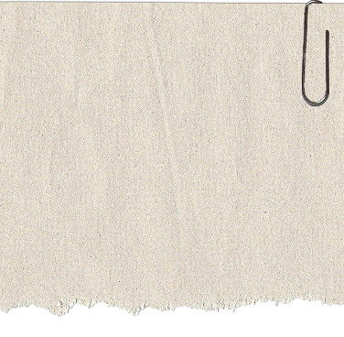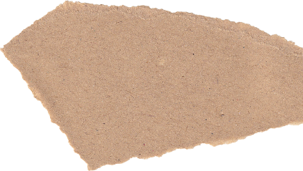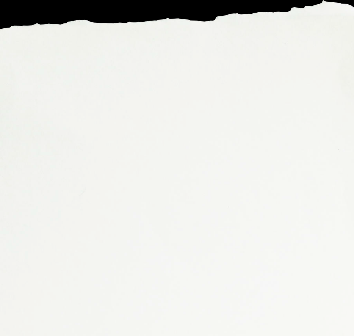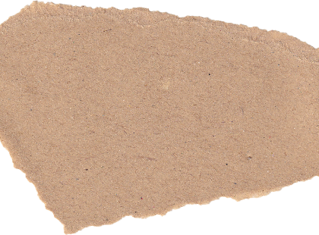

**PSHE**

**Design and Technology**

Exploring Watercolours

Children will experiment with watercolours and learn about the many special characteristics of this media. We will recap our knowledge of primary colours and experiment with colour mixing to develop our knowledge of secondary colours.

**Computing**

**What is the weather like in the UK?’**

Even though this is a hard question to ask as the weather is so unpredictable, we will be looking and identifying the four different countries in the UK and look at where we live specifically. The children will be able to identify the four seasons and observe and describe daily weather patterns. We will be learning to use the compass directions to describe the location of a feature and explain what the weather tends to be like during each season in the UK. We will also be looking at what clothes are appropriate for each season and what different activities you can do.

**Art**

**Geography**