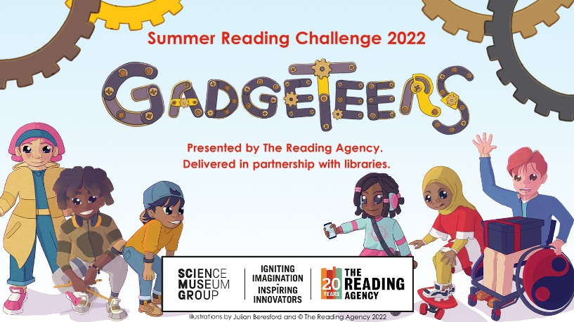

Children often have a dip in their reading over the summer, the Summer Reading Challenge, produced by the Reading Agency and delivered by libraries, has been proven to stop this as well as changing children’s attitudes in a positive way towards reading and libraries. The challenge is for 4-11 year olds to read 6 library books over 8 weeks of the summer in return for various fun prizes, including a medal and certificate on completion. This year the challenge runs from Saturday 16 July to Saturday 10 September.

This year’s theme, ‘Gadgeteers’, is all about science and innovation. Developed in partnership with the Science Museum Group, the Challenge will inspire children to use their curiosity and creativity to discover the science behind the everyday and celebrates the role of the imagination in both reading and the sciences. Although there is a science theme, children can read any six library books of their choice; they don’t have to be linked to science and they can read more than six books! They also don’t have to be able to read, reading with a parent/carer also counts.

It’s free to join the challenge and to take out a library membership, visit: Join the library - Wiltshire Council and library staff will be on hand to support reading choices. Children can also take part in the challenge online via the website: summerreadingchallenge.org.uk, where they can rate and review books, download activities, and access video content, games and quizzes.

