Dear Parent/Carer,
Great news! Your child has the opportunity to take part in Bikeability training provided by Wiltshire Council.
Course dates | Monday 6th and Tuesday 7th June 2021
Bikeability Level(s) | Level 1 & 2
Year Group | Year 6

HOW TO BOOK:
Please complete and return the consent form to school as soon as possible.

COST: There will be no charge for the Bikeability programme. A huge thank you to our FONTS PTA for sponsoring the programme so that every child can participate at no cost.

WHAT IS BIKEABILITY?
Bikeability is the national cycle training programme supported and subsidised by the Department for Transport. The cost of the programme is therefore £5.45 per child. But, as mentioned earlier, our school PTA are funding every child so participation is free. The course builds the skills and confidence of children who can already ride. Cycling is a life skill with many benefits; it encourages independent mobility, is great for the environment and improves physical and mental health. Evidence shows Bikeability helps more people cycle, more safely, more often and prepares them for a lifetime of cycling. All our Bikeability training is delivered by qualified, professional, DBS-checked National Standard Instructors. Visit www.bikeability.org.uk for more information

COVID-19:
The Bikeability delivery guides that all registered Bikeability providers must follow were updated in August 2020 in line with current Government guidance on implementing Covid-19 protective measures in schools. Wiltshire Council has updated local Bikeability policies and procedures in place (copies available on request). No instructor or participant will be allowed to take part in training if they, or a member of their household display symptoms of COVID-19 or have been advised by NHS Track & Trace to isolate.

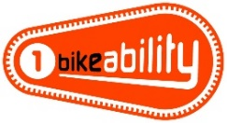
The Bikeability Level 1 course helps children become more skilled and confident in riding their bikes in the playground and gets them ready for cycling on the road. Riders must be able to ride a bike - pedal and freewheel- to participate in this level.
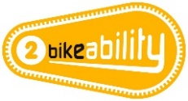
The Bikeability Level 2 course aims to improve riders’ skills and confidence for cycling on smaller roads and simple junctions without too much traffic. It prepares riders for cycling on larger and busier roads and more complicated junctions. All the riders will have to show the instructors they can do everything at Bikeability Level 1 before they can go on the roads.
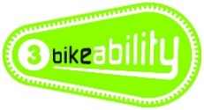
The Bikeability Level 3 course aims to develop riders’ skills and confidence so they can ride in some everyday road environments, including busy roads and complex junctions. Riders must have achieved everything at Bikeability Level 2 before moving onto the Bikeability Level 3 course.
In summary, Bikeability teaches riders to make independent decisions and practice safe and responsible cycling, through:
- Making good and frequent observations
- Choosing and maintaining the most suitable riding positions
- Communicating intentions clearly to others
- Understanding priorities on the road, particularly at junctions.
For your child to participate in this course you will need to provide and check the following:
Your bike - make sure you check that your bike is in good working order, with the tyres inflated and the moving parts working well. If you need to take it to a bike shop before-hand, don’t leave it to the last minute!
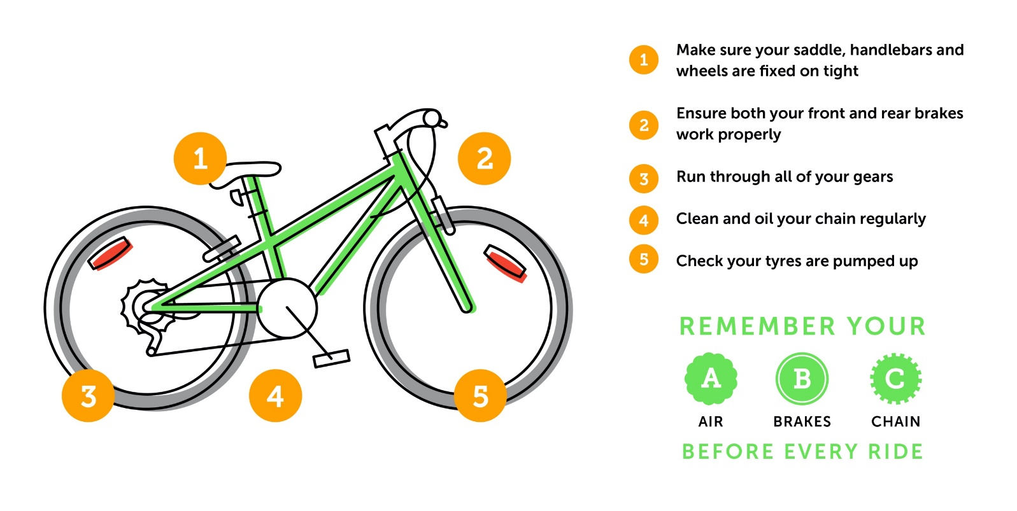
Your helmet - your helmet should sit comfortably and level on your head, (not too tight or too loose), with the peak sitting about two fingers width above your eyebrows. The side adjusters should sit just below your ears with the straps forming a nice ‘V’ on the side of your head, and the chin strap should allow for one finger to fit between it and your chin.
Your clothing - wear comfortable clothing that allows you to ride easily, including shoes that fit securely, such as trainers. Be prepared for the weather to change! On cold or wet days, make sure that you have your coat and gloves, and an extra layer or two. On warm, sunny days use suncream and bring a bottle of water.
Your hand sanitiser – please bring your own supply of hand gel, sanitiser spray and/or wipes for your personal use during the session. Face coverings are not required during training and may cause dangerous distractions if worn.
Important cycle, helmet and clothing guidance is available at www.bikeability.org.uk/get-ready/
Wiltshire Council does not maintain any personal accident cover and is only insured against its legal liability to third parties if they are injured or their property is damaged during any cycle training organised and approved by the Council. Parents/carers of pupils participating in cycle training are advised to make their own arrangements to insure their children against personal accident, loss or damage to their cycles or other personal effects.
If you have any questions regarding Bikeability training in Wiltshire, please contact the Road Safety team at bikeability@wiltshire.gov.uk or 01225 713700
If you want to find out more about Bikeability in general, visit www.bikeability.org.uk

Please read the following information carefully and return a copy of your completed form to school by Monday 23rd May 2022.
I agree to the following:
- I am responsible for ensuring my child has a roadworthy cycle for training and if I am in doubt as to whether a cycle is roadworthy, I should seek the advice of a professional mechanic (Instructors will refuse participation if the cycle is unsafe.).
- I understand that if my child disrupts the course so that their safety or the safety of anyone else is put at risk, they will not be allowed to continue with the course.
- I will notify the school immediately if my child, or anyone in their household develops symptoms of COVID-19 before training or between sessions, or if they are advised by NHS Track & Trace to isolate.
- Wiltshire Council will not be responsible for any injury or disease transmission or liable for any loss or damage to participant’s cycles and other belongings.
- I will provide a suitable cycle helmet that fits my child’s head correctly.
- I will ensure my child is appropriately clothed for the weather.
- I will encourage my child to practice between sessions and support their cycling after training.
- I understand the information given below will shared with my child’s Bikeability instructor prior to the start of the course. (After training is completed, Wiltshire Council will only keep a record of your child’s name and school for audit purposes in relation to Department of Transport Bikeability funding.)
- I confirm that I have read all the information and consent to my child participating in cycle training and related activities, which may include cycle maintenance as well as riding on the public highway.
Child’s full name:
School attended:
To help us assess your child’s training needs, please tell us if they can already do the following without stabilisers or assistance:
- Look behind while pedalling in a straight line
- Pedal one-handed in a straight line (both hands)
They MUST be able to do so for Level 2 training on the road
Does your child have any medical/ educational needs we need to be aware of, including allergy to hand sanitiser?
Is your child ‘clinically vulnerable’ and at ‘moderate risk’ from Covid-19 according to current NHS guidance? |  | Does your child live with someone who is ‘clinically vulnerable’ or ‘clinically extremely vulnerable’ from Covid-19 according to current NHS guidance?
Parent/carer name and/or signature:
Date:
If you are happy for your child to be photographed and/or filmed to help promote Bikeability, please tick here

